XNA Game Tech

Computer Pong
Software Specification Documents

Version 1.3

Meeting Minutes & Revision History

Date | Version | Description | Author | Attached Documents
2/27/09 | 1.0 | Draft | Kanhar Munshi | Appendix A1
3/11/09 | 1.1 | Draft | Jayati Das, Kanhar Munshi | Appendix A2
3/12/09 | 1.2 | Final | Mel Ibiz, Kanhar Munshi | Appendix A3
4/3/09 | 1.3 | Revise | Jayati Das

XNA Game Tech Team

Name | Position
Jayati Das | Lead Developer
Kanhar Munshi | Project Manager
Vlad Akilov | Developer
Mel Ibiz | Developer / Architect

Table of Contents

1. Introduction
1.1 Purpose 3
1.2 Specification and Scope 3
1.3 Definitions, Acronyms, and Abbreviations 4
1.4 References 4
1.5 Overview 4

2. Overall Description
2.1 Use-Case Model Survey 5
2.2 Use-Case Diagram 6

3. Specification Requirement
3.1 Use case Scenarios 8
3.2 Class Diagram 14
3.3 Finite State Machine 15

4. GUI Specification
4.1 Introduction 16
4.2 Design Tools 17
4.3 Use Case VS 2008 GUI Predicted Specification 18

Appendix:
A1- Meeting Revision- 1 1
A2- Meeting Revision- 2 2
A3- Meeting Revision- 3 5
B- Class Diagram Full View 6
C- FSM Full View 7
Software Requirements Specification

1. Introduction

  - Purpose
The purpose of this project is to develop a simple PC clone of the classic arcade game, Pong. Pong is a computer game which simulates table tennis (ping-pang), or tennis loosely if you prefer, from a bird’s eye perspective.

The system will consist of multiple user and different user can do different operation based on there user specifications. This Document will describe specification and role of various user and detail features of the system.

City Pong is intended to be a system where users play pong game and manage their account. Users, depending on their system status, have different functions that they can do.

  - Specification and Scope:
Here we describe what City-Pong features are in the scope of the software. The player controls an in-game paddle by moving it vertically across the left side of the screen, and can compete against another player (or more, if you choose) which controls a second paddle on the opposing side. Players use the paddles to hit a ball back and forth. The aim is for a player to earn more points than the opponent. Points that are earned when the other player misses the ball. The first player to reach 11 points will win the match.

There will two types of users in the system, players (PR) and system administrators (SA).

In Scope:
- System Administrator manages the list users and their account. System Administrator can approve, deny or reject any user.
- A player can play game with another player.
- Player can view his/ her record and edit profile.

  - Definitions, Acronyms, and Abbreviations

Acronyms and Abbreviations
- PR: Player
- SA: System Administrator.
- AU: Anonymous User
- GUI: Graphical User Interface.
- FSM: Finite State Machine.
- DB: Database.
- ER: Entity-Relation.

1.4 References
Appendix A:

  - Overview
Section 2 and 3 describe diagram and detail specification requirements. Section 4 Is first view of our GUI prototype. And appendix has other documents such as our draft from Meeting Minutes.

2. Overall Description

2.1 Use-Case Model Survey

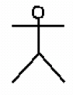 Anonymous User

Fig 2.1 Anonymous User use-case character
New User – A Anonymous User is a user that is not registered on the system.

Player (PR)

Fig 2.2 Player use-case character
Ordinary User – The Player is a user that has is a registered user of the system. Who can play game and edit/view his/her own account.

System Admin (SA)
Fig 2.3 System Administrator use-case character
System Administrator – The System Administrator is a user that is registered on the system. Who mainly manage the system. SA can approves or denies a player. They cannot play game.
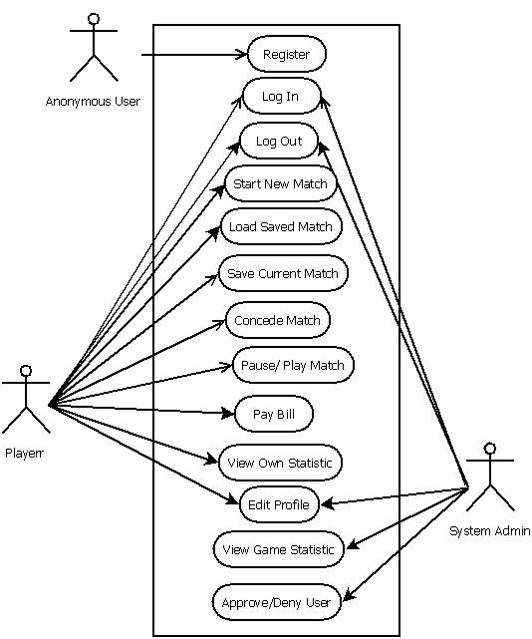
Fig 2.4 The System Overview Use-Case

Register – Anonymous user who doesn’t have any account yet can register using this.
Log In – Any two users who want to play a new game or load a game have to go though this function.
Log Out – A user who already logged in can Log out before they exit. That will disable main application functionality.
Start New Match – By this function two register users can start a New Match.
Load Saved – A saved game can be reload by this function. Two specific user have to login if they want to restart a saved game.
Save Current Match – A match can be closed and saved for future reload using this function.
Concede Match – Any Player can concede a Match while they are playing match.
Pause/Play Match – A player can passed and restart a match using this function.
Pay Bill – User can recharge their Pong-point using money from their account balance.
View Own Statistic – A player can View statistics of games that have been played by him/herself using this function.
Edit Profile – By this function a Player can update his/her profile information. A System Admin can edit any player’s profile. Such as setting status of a player “Banned” because of not paying the bill.
View Game Statistic– Using this function a System Admin can view system statistics of users and games that have been played.
Approve/Deny User – Using this function a System Admin and approve or deny any anonymous user who requested for register.

3. Specific Requirements

3.1 Collaboration Diagrams:
A. Register

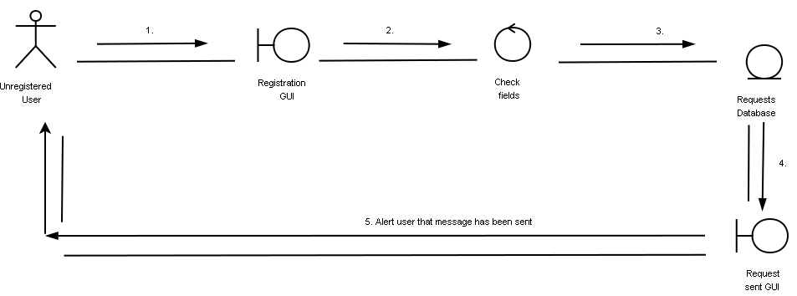

Normal Scenario:
- Enter Registration Information
- Send Registration Information
- Store Request in Database (XML File)
- Raise Event if database store is successful
- Show confirmation message that request has been sent if information is successfully stored in the database.

B. Play New Game
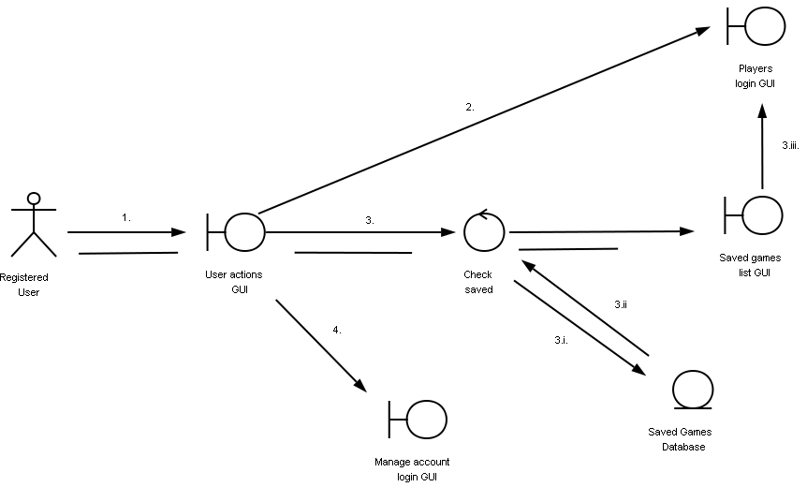

Normal Scenario:
- Select An Option.
- Select play new game
- Select load game
  - Query database
  - Retrieve saved games
  - Select saved game
- Select manage account

C. Load Saved Game
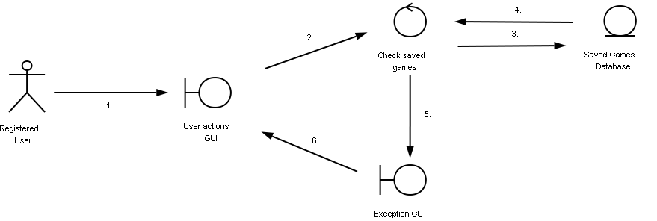
Normal Scenario:
- Select option
- Load saved game
- Query database
- Return saved game info
- Alert user, No saved games
- User selects back

D. Login 2 User

Overview:
Two Login box display side-by-side. Any user can enter user id and password anytime. Once both user enter correct user id and password Proceeded to game GUI.
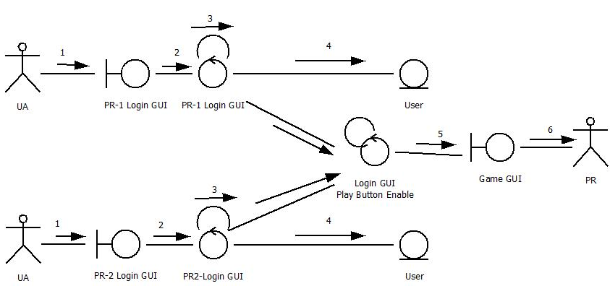

Normal Scenario:
- Anonymous User come to Login GUI
- User Enter User Id and Password
- Display Id and password Input box until valid login
- Verify the data with the user database every time user enter the id and password
- Proceeded to Game Play if Both user login success fully
- Player start playing game

E. Save Game
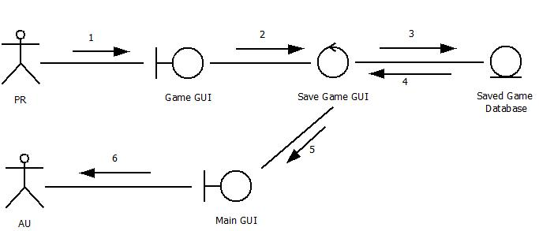

Normal Scenario:
- Player Playing Game
- Player select Save Game
- Send the game information to the database
- Received Game Saved confirmation
- Return to Main GUI
- Player Become Anonymous User

F. Paused Game
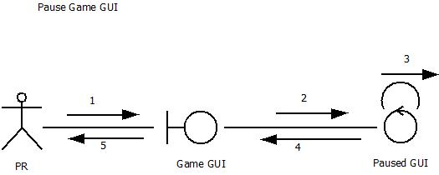

Normal Scenario:
- Player Playing Game
- Player select Pause Game
- Continue to display pause Game GUI and hold Game Loop and Play Input
- Player Select Restart Game
- Return to back to Game Play
- Player become active with game play

G. Game Over
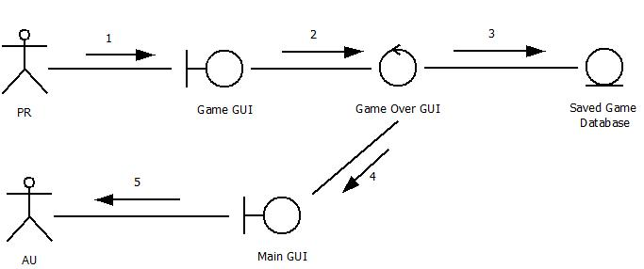

Normal Scenario:
- Player Playing Game
- One of the player win the game
- Send the game information to the database
- Received update Game History confirmation
- Return to Main GUI
- Player Become Anonymous User

H. Concede Game
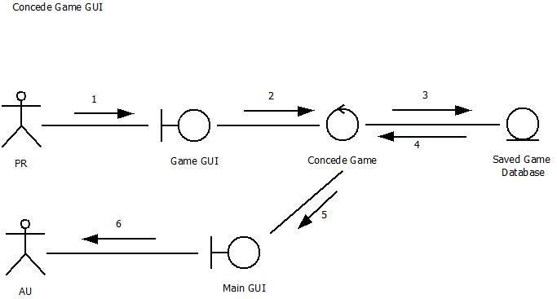

Normal Scenario:
- Player Playing Game
- Player Select Concede Game
- Send the game information to the database
- Received update Game History confirmation
- Return to Main GUI
- Player Become Anonymous User

I. Login 1 User
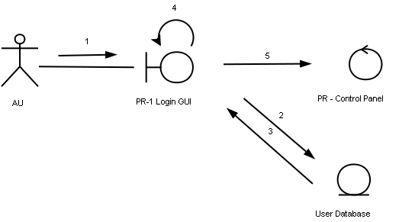
Normal Scenario:
- Anonymous User (AU) enters login credentials
- Credentials are sent to the database, for verification
- Verification Results are returned from the database to the program.
- If login credentials are successful, AU assumes the properties and privileges of a PR.
- Player can now continue to Player control panel

J. Pay Bill GUI
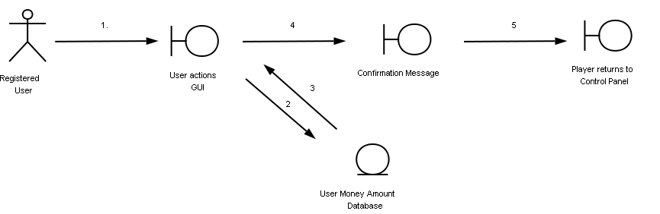
Normal Scenario:
- Enter Desired Money Amount
- Send Request to Database
- Database updates, player’s Total Money available.
- If update is successful, players see a confirmation message.
- Player returns to player Control Panel

K. Edit Profile
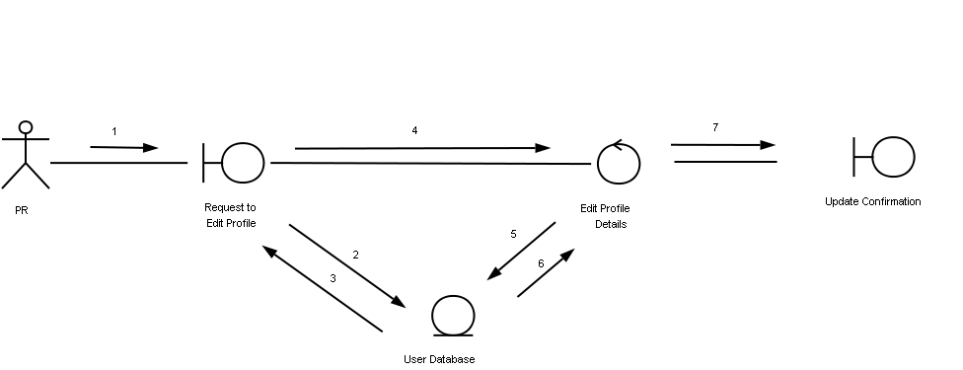
Normal Scenario:
1. Player Clicks on Edit Profile
2. Request to Database is sent querying players profile.
3. Database returns player’s profile details.
4. Player can edit any or all details in editable textboxes.
5. Player hits submit, and a request is sent to the database to update user profile.
6. Database returns the status of this update.
7. If Successful, player gets an update confirmation.
8. Player returns to control Panel.
L. Approve/Deny Player
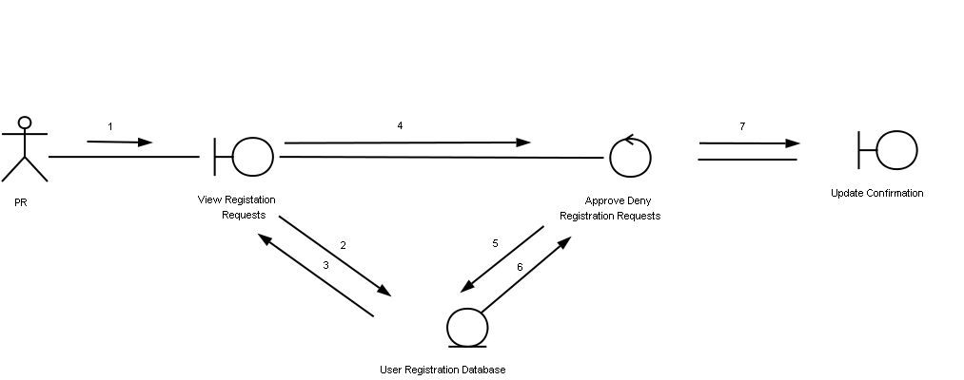
Normal Scenario:
1. System Administrator clicks on Approve/Deny Player
2. Request is sent to Database to retrieve list of new registration requests
3. Database retrieves the above information
4. SA Views registration requests.
5. The approvals/rejections are sent to the database to update.
6. Database returns an update confirmation
7. SA sees a confirmation message if database update is successful.

M. View Match History
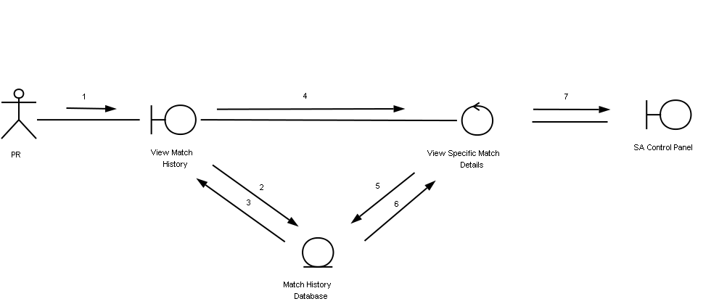
Normal Scenario:
1. SA clicks on View Match History
2. Request is sent to database, querying list of Matches
3. Database returns list of Matches
4. SA Clicks on any one specific match
5. Request is sent to database, querying details of one specific match
6. Database returns specific details
7. SA returns to Control Panel.
3.2 Class Diagram
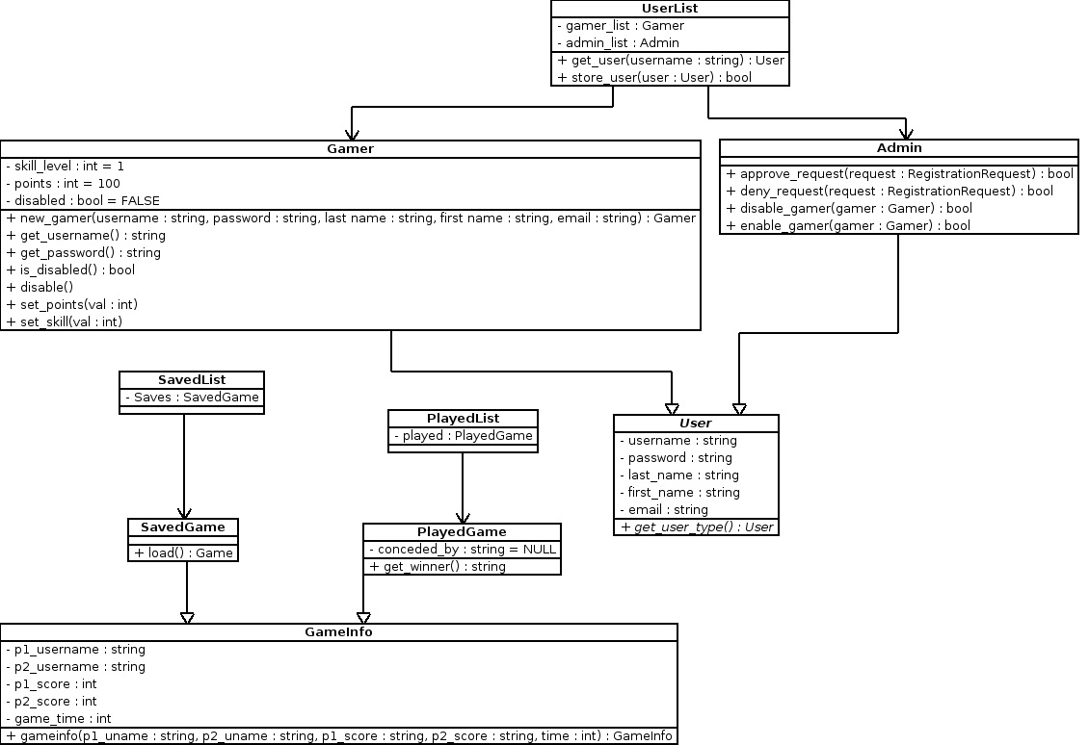

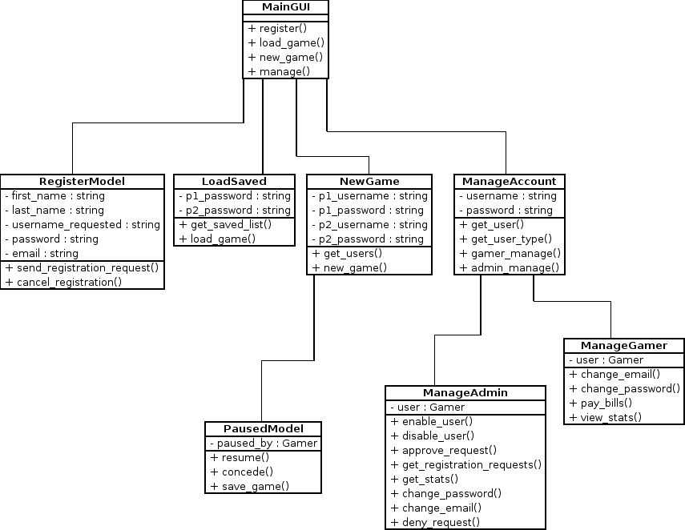

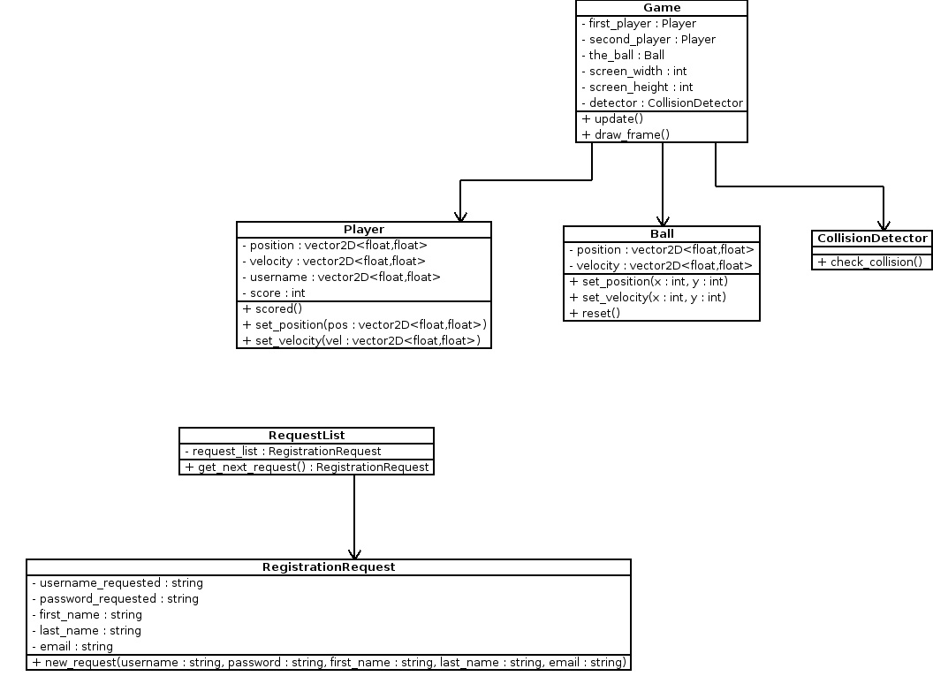

Figures: Class Diagram / Structure

3.3 Finite State Machine

The FSM below illustrates a generalized functional overview of our system, which when implemented would preserve the essence of the tree structure as displayed below.

While new functionality may be added, or subtracted from the below, the FSM serves as a guideline for future GUI development.

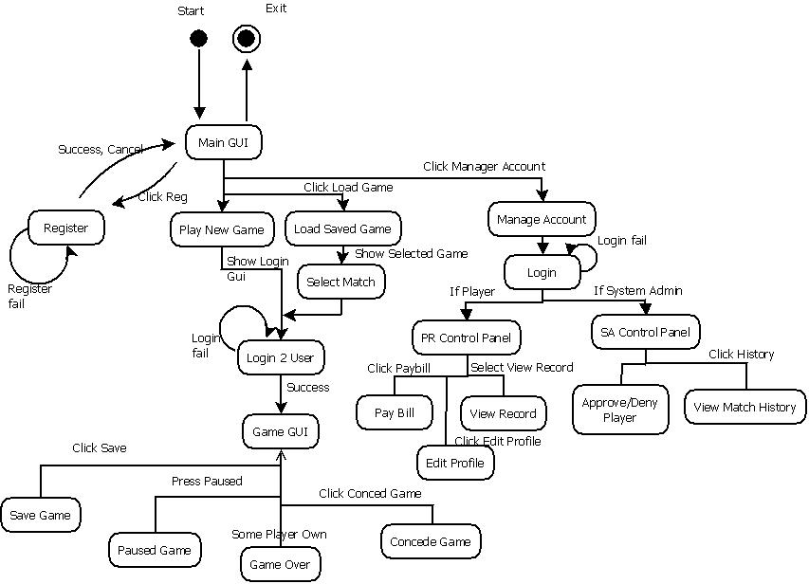
Finite State Machine / Chart – Pong

4. GUI Specification

4.1 Introduction

The GUI specification entails rough sketches of expected program output, for initial customer feedback, and for legal reasons.
A key component of the waterfall methodology of program development is the granularity of different steps involves, alongside an incrementalist approach to the project.
At this point, the GUI is ideally designed using the same tools that will eventually design the game interface (screen) in order to maintain consistency in expected output. In addition to this, considerable time is saved since the Visual objects (toolbars, listboxes, textboxes, label, form inputs, buttons) do not need to be recreated and the associated panels are embedded in their appropriate places.

4.2 Design Tools

For the above reasons, all of the following were designed in Microsoft Visual Studio 2008, using the XNA framework 3.0. The solution file of the project below illustrates the project which is in its development stage, but has the main structure drawn out.

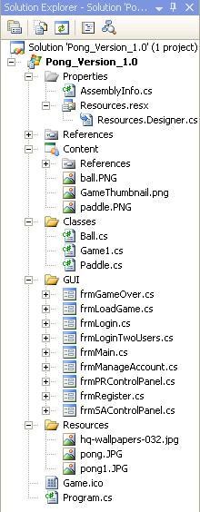

Solution Explorer

4.3 Use Project GUI Specifications

Rough Expected Pong Game Screen

- The key components are the two paddles, and a moving ball frame.

- The Windows Panel allows the user to Hit the Cross button to Exit at any tie

- The final Version will have support for changing backgrounds, and an updated Game Score and Statistic

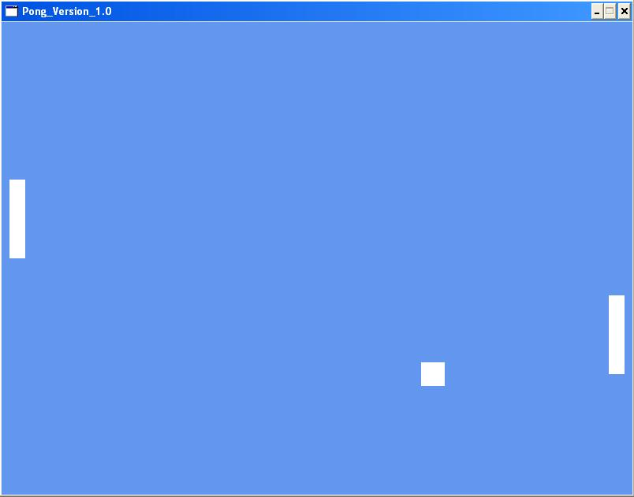
Minimalist Game Screen Design

Graphical User Interface (Entry Point)

- Main GUI, serves an entry and Exit point for the Application, for all users.

- Allows the SA and the user to Login, Manage their profiles, and for the user to play a new game, or load a saved game.

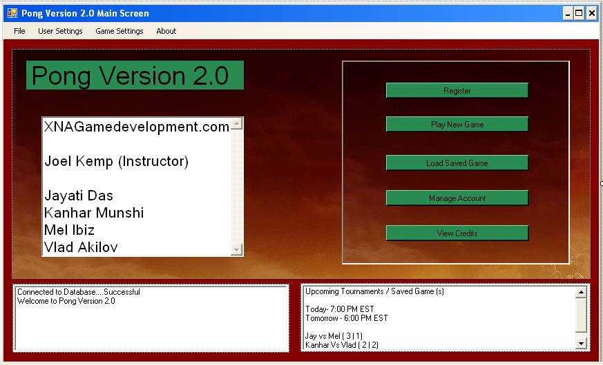
Main Entry Screen

Game over Screen

- Serves as an Exit point for the application, to centralize the exit procedure.

- This helps as the program can now free game resources, and display a thank you message for playing, and redirect to the teams blog (http://xnagamedevelopment.blogspot.com) for more games or game updates.

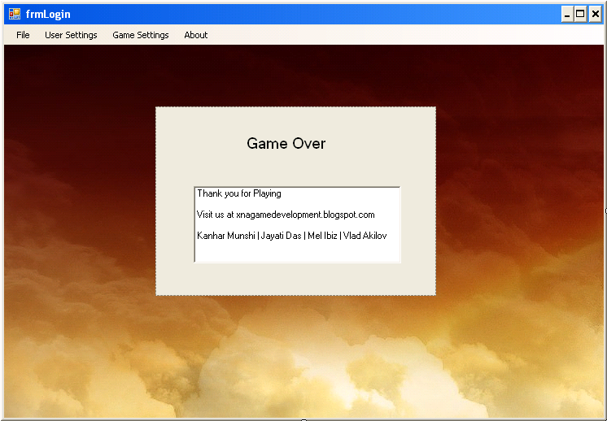
Game Over Screen

Load Saved Game

- Allows Registered Users to Load Saved Game

- Users can see a list of saved games in the system.

- User can pick a saved Game and will be redirected to login screen where the other user must also login for the Load to be successful.

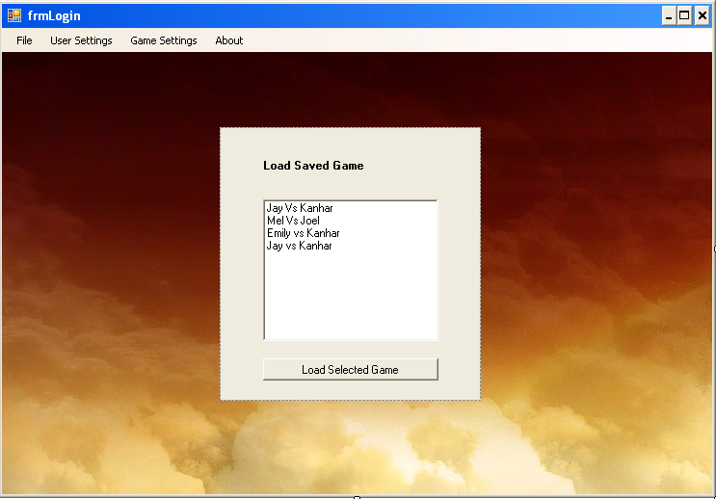
Load Saved Game

Login Only One User (Not for Playing a Game but for SA / User Profile Modification Purposes)

- Allows SA to login to go to SA Control Panel

- Allows User to login to modify his profile

- User can decide to login, and play game, but then he must wait for second user to login in the game screen.

- User can perform all his Use Case functions after logging in.

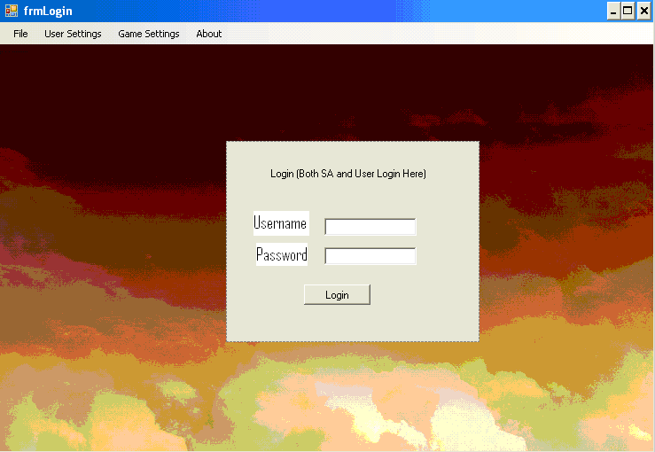
Login One User

Login Two user Screen (To play Game)

- Disallows SA from entering.

- Allows only Users to login to play a game

- Both users must login in order to be able to play.

- User can only play game after logging in since the system cannot remember which user can modify his details.

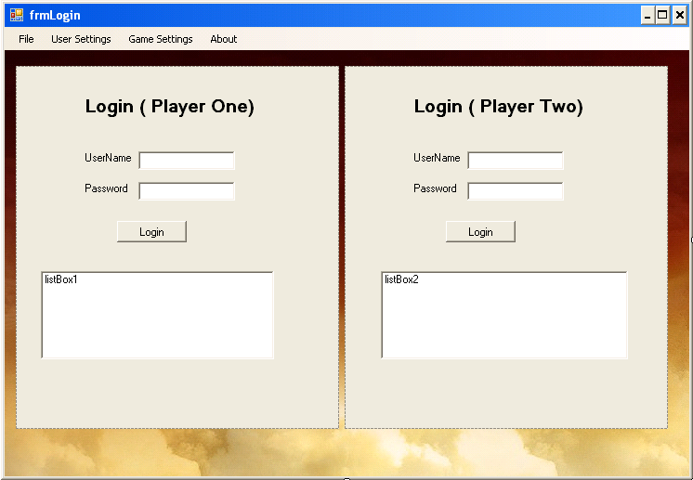
Login Two Users

User (player) Control Panel

- Disallows SA from entering.

- Allows only Users to login

- User can pay Bill

- User can view Score statistics.

- User can edit profile.

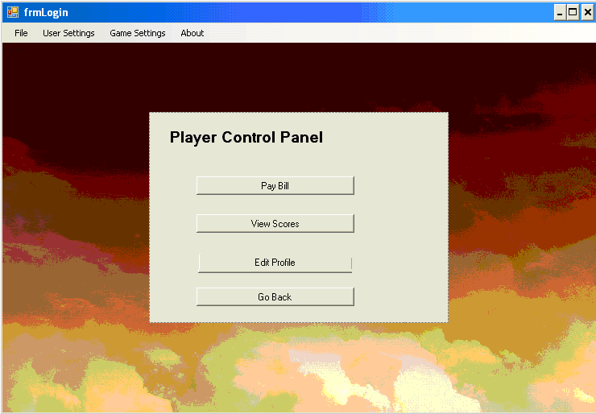
Player (user) control Panel

Register Anonymous (New) User

- SA Does not need to enter details; he has a pre-assigned username and password.

- Allows only new Users to register

- User must type in all the appropriate details, not listed below including username, password, email, first and last name.

- All fields must be complete.

- User will receive a Confirmation popup saying Registration request successfully sent and be redirected to Main GUI.

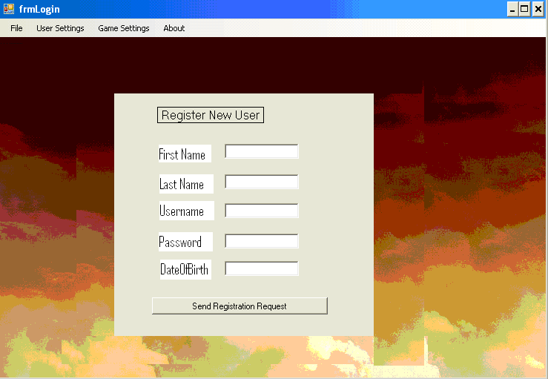
Register New User

System Admin (SA) Control Panel

- SA can approve deny users

- View / Modify Match History.

- Edit Game Settings and Heuristic Engine

- Go back to Main GUI

Ended.
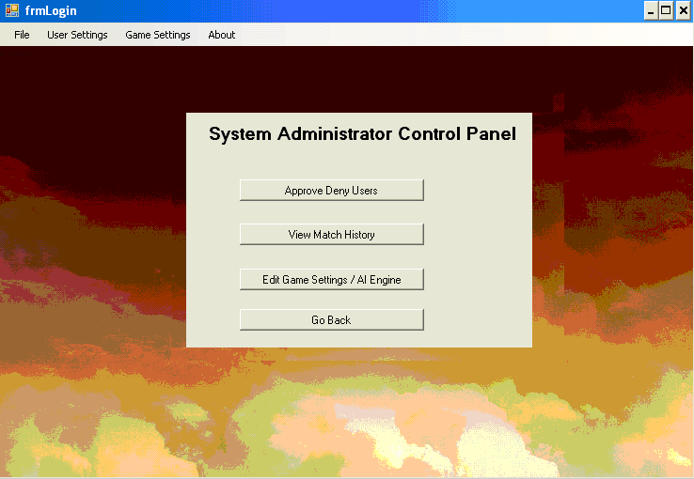
System Administrator Control Panel

